2013-UA-01-4.odt Colourful Table

0 ---- | I: ----- | II: medium | III: easy | IV: easy

Answer Type: Multiple Choice (may be interactive)

Body

A little beaver would like to pave his new room with different coloured tiles:
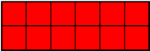
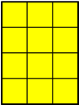

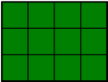
He decided that he will not rotate or cut the tiles in any way.


He wants to make his room as colorful as possible.

Question

What is the maximum number of different colours he can use to pave the room in the picture?
- 2
- 3
- 4
- 5

Answer

c) 5

Explanation
All kinds of tiles can be used to pave the room. For example:
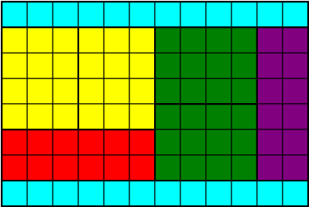

It's informatics

The partition on the subsets of given sizes is one of the classical problems in the Algorithms theory.
It is packing problem, where we have an area and we decide how to cover the area with certain shapes.

Keywords

Partition, graphical algorithm

Websites

Internal Use

Wording

Comments
Christian Datzko, Switzerland, christian.datzko@edubs.ch: the same comments as for 2013-UA-01-1 apply, see ../2013-UA-01-1/2014-UA-01-review.ods.

Špela Cerar, 2014-06-03: could be interactive, changed wording, vector graphics should be made

Peter Garscha, Austria, peter@rlsux.com, 2014-06-03: svg-graphics missing, it's informatics need more explanation.

Ahto Truu, ahto.truu@ut.ee (2014-09-25): regenerated all graphics in SVN and PNG.

Files

2013-UA-01-4.odt (this file)
floor8x12.png
floor8x12.svg
tile1x12cyan.png
tile1x12cyan.svg
tile2x6red.png
tile2x6red.svg
tile3x4green.png
tile3x4green.svg
tile4x3yellow.png
tile4x3yellow.svg
tile6x2purple.png
tile6x2purple.svg
floor8x12answer.png
floor8x12answer.svg

Authorship

author: Maria Hasanova, osvitarda@rambler.ru
translating: Lesia Ilishchuk, ilishchuk@i.ua
review: Špela and Maciej

License

Copyright ©2013 Bebras - International Contest on Informatics and Computer Fluency.
This work is licensed under Creative Commons Attribution-NonCommercial-ShareAlike 3.0 Unported (CC BY-NC-SA 3.0).
Visit: http://creativecommons.org/licenses/by-nc-sa/3.0/

